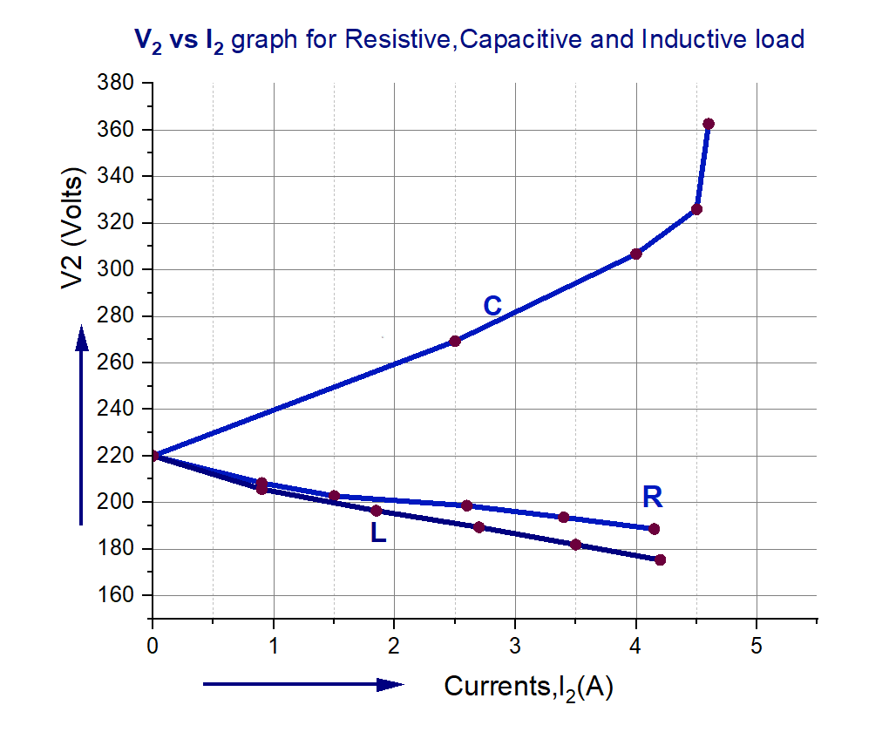

**Figure 01: Output Voltage versus Output Current Graph for**

**Resistive, Inductive and Capacitive Load (Ð-Connection)**

**VR vs (I2)** Graph for Resistive, Inductive and Capacitive Load

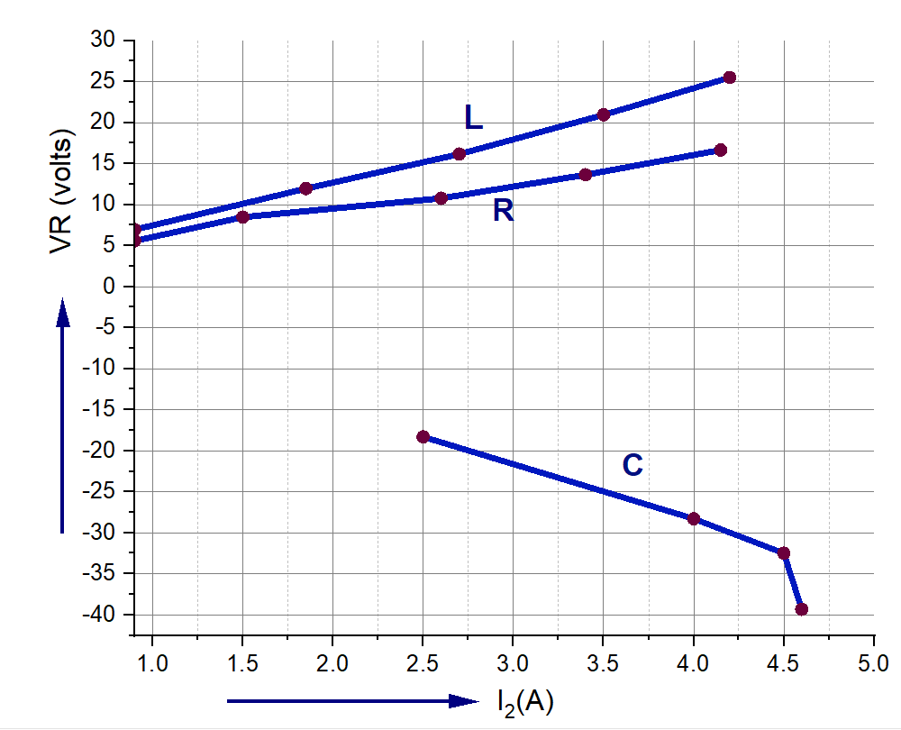

**Figure 2: Voltage Regulation (VR) vs Currents (I2)** **Graph for**

**Resistive, Inductive and Capacitive Load (Ð-Connection)**